


WooCommerce Connector Capabilities Guide



By Synfynal
WooCommerce Connector
WooCommerce Connector eliminates manual data entry by seamlessly synchronizing your WooCommerce store with Dynamics 365 Business Central. A quick, one-time setup enables automatic data flow between both systems, saving countless hours of work.
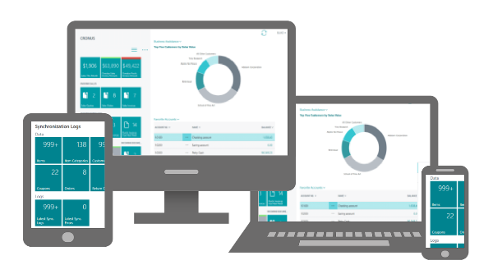

The WooCommerce Connector can seamlessly integrate your WooCommerce store with Microsoft Dynamics 365 Business Central, combining the power of both platforms. WooCommerce powers over four million online stores, while Business Central, a cloud-based ERP, supports 40,000+ businesses in managing finances, sales, services, and operations.

Quick View
🚀 Multi-Store Synchronization
Seamlessly synchronize multiple WooCommerce stores with Business Central for centralized management.
🔑 Authentication and Setup
Securely store authentication credentials for each WooCommerce store.
Easily set up new stores with a guided setup wizard.
⏳ Flexible Synchronization
Customize synchronization frequency and automate data updates between WooCommerce and Business Central.
Ensure accurate, real-time data flow with two-way synchronization for items, customers, and orders.
📦 Product and Inventory Management
Keep items, prices, attributes, categories, and variants synchronized across both platforms.
Use the Smart Mapping Tool to link existing products and avoid duplicates.
Maintain accurate stock levels with real-time synchronization.
Set default values for new items per store with customizable item templates.
👥 Customer Synchronization
Synchronize customer records, contact details, and order history across both platforms.
Avoid duplicates by connecting existing customers with the Smart Mapping Tool.
Define default values for new customers per store using customer templates.
🛍 Order Management and Processing
Automatically synchronize sales orders, including tax and shipping details.
Define a unique number series per store.
Filter and selectively synchronize orders based on status.
Automatically create customers and items for new orders.
Track order status at every stage of the lifecycle.
Mark webstore orders as completed once invoiced.
📊 Logging and Error Handling
Access detailed synchronization logs for full visibility into successes and errors.
An automated job queue guarantees consistent, reliable synchronization.
⚙ Customization and Extensibility
Extend the WooCommerce Connector with add-on modules to support both B2B and B2C business models.
Need a custom feature? Our development team can create tailored solutions to meet your unique business needs.
Reliability
Stay running without interruptions. The WooCommerce Connector delivers 99.9% uptime for seamless performance.
Save Time
Save time by eliminating manual entry. Automate your workflow and focus on what matters most.

Pricing
Only pay for what you use. Your monthly cost is based on your synchronization usage.
Free Trial  $0  Valid for 2 weeks |  | Basic Sync  $60  Every month |  | Light Sync  $125  Every month |  | Medium Sync  $175  Every month |  | Heavy Sync  $250  Every month
15-day free trial of WooCommerce Connector |  | Synchronize between 0 and 50 sales orders per month |  | Synchronize between 50 and 200 sales orders per month |  | Synchronize between 200 and 500 sales orders per month |  | Synchronize over 500 sales orders per month
Start for FREE now! The 15-day free trial includes unlimited synchronization.
To get started, go to: www.synfynal.com/contact-us
Support


We prioritize exceptional customer support to ensure you get the most out of our solutions. Our team provides timely, effective assistance when you need it.
Contact us through our support portal at: https://www.synfynal.com/contact-us

Become a Partner
Join us in empowering businesses by facilitating seamless integration between Microsoft Dynamics 365 Business Central and WooCommerce. Discover the benefits and opportunities that come with being a Synfynal reseller.


Why partner with us?
- Cutting-edge integration
- Lucrative commission
- Training opportunities
Partner Responsibilities
- Implementation and support
- Developing customizations
- Optional translation services

Get started today by contacting us to discuss how our reseller program aligns with your business goals. Together, we can unlock new possibilities for businesses through efficient integration.
Additional Resources
Synfynal.com | https://synfynal.com
Business Central | https://www.microsoft.com/en-us/dynamics-365/products/business-central
WooCommerce | https://woocommerce.com/

